Birmingham Canal
Navigations Society
Exploring the Titford Pools
We are keen to help to regenerate the Titford canal, Pools and adjoining public open space. As part of this project, we want to increase the number of boats navigating the pools and are giving a plaque to any boat navigating the both pools for the first time. Just fill in this form and follow the instructions.
Boat name …………………………………………………………………………………….
Skipper …………………………………………………………………………………………
Address ………………………………………………………………………………………..
…………………………………………………………………………………………………...
Post code……………………
Email address: ……………………………………………………………………………….
Date that the Pools were navigated ………………………………………………………
I have navigated both of the Titford Pools, BCN.
Signed…………………….............................
Please note any comments regarding difficulties experienced on your cruise or any other issues that you think should be considered in our plans for the regeneration of the Titford Canal and Pools.
The easiest way to get your plaque is to hand the form in at a BCN Society event, and we will give you the plaque on the spot.
If this isn’t convenient, please send form accompanied by a photo of proof of navigation & a cheque for £1.50 to ‘BCN Society’ to cover postage to
Barrie Johnson, 7 Moat Farm Drive, Bartley Green, Birmingham, B32 4LH
Provided they are identified, photos can be emailed to info@bcnsociety.com
If you are going up in company, we are entirely happy for the photo of your boat to be taken from the other boat, and you take a photo of theirs. (It is difficult to get a decent photo of your own boat when you are on it.)

Navigation notes
We recommend that boats travel with at least one other boat to assist in case one of them runs aground. Motorway silt means this is a possibility. Depth in the middle of the pools is reasonable.
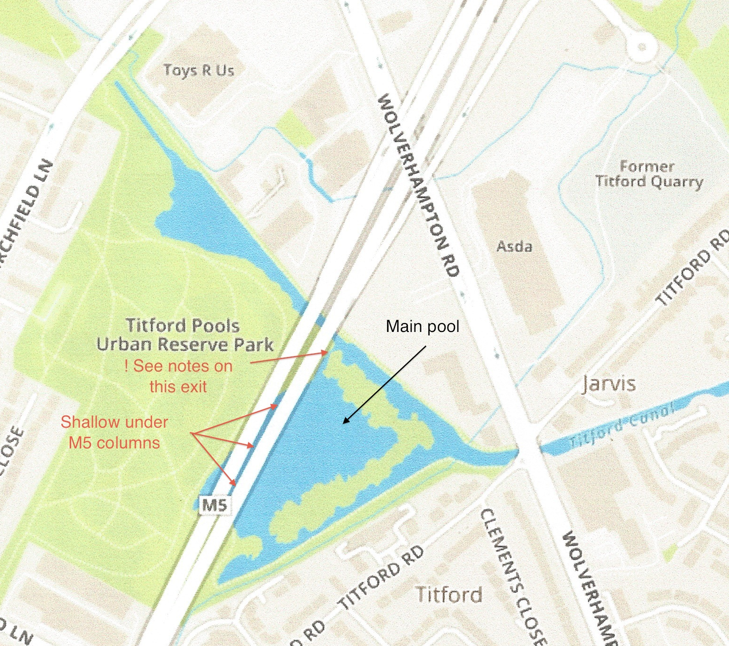
There are two branches leading to the pools.
Portway Branch – this runs South West from Jarvis Bridge (Wolverhampton Road Bridge. A right turn from this branch takes you in to the main pool. (A left turn out of the pool to this branch is also fine.
In the main pool, the area under the motorway is getting shallow. While there was plenty of depth there in the past, I have proven conclusively that it is now too shallow to take a 32” draught boat. (The problem is silt coming off the motorway)
Causeway Green Branch – running North West from Jarvis Bridge.
While running from Jarvis Bridge, a left turn from this branch in to the main pool is fine (though beware of the failed bank on the towpath side).
The turn left from the main pool, going under the motorway to the small pool, is not recommended – it is shallow, and the width of the canal at this point makes things very difficult. However I do know of a 57’ boat that has made this turn, though it was something of a multipoint turn, not a simple “turn left”. The same advice applies in the opposite direction.
Straight ahead on the Causeway Green takes you under the motorway to the small pool. This pool is shallow at the edges – we recommend winding in the middle.

